**Assignment no 3:** Create 3 repositories having 3 index.html file one in each repository. And you have httpd server installed on your server. Now whenever you push any changes to any repository the index.html of that particular repository will be deployed on our httpd server.

Step1 : Crated 3 repositories as repo1, repo2 and repo3

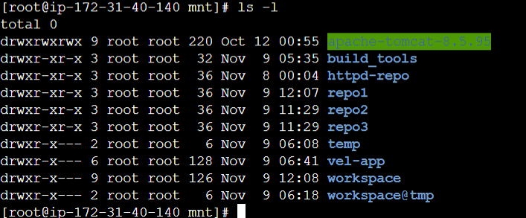

Sep 3: Also created 3 different GitHub repositories as repo1, repo2 & repo3

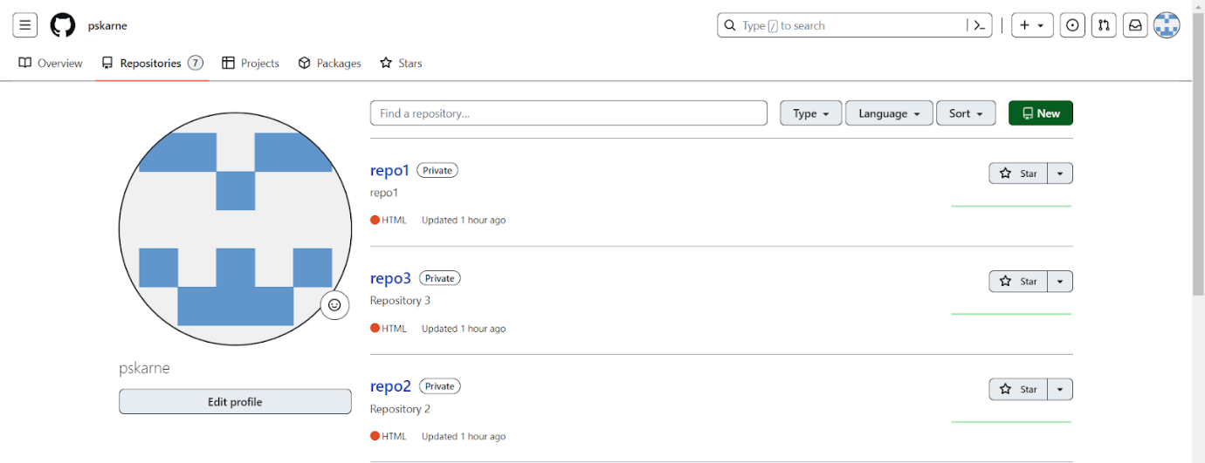

Step 3: Created 3 jobs in jenkins as repo1-job1, repo2-job2, repo3-job3

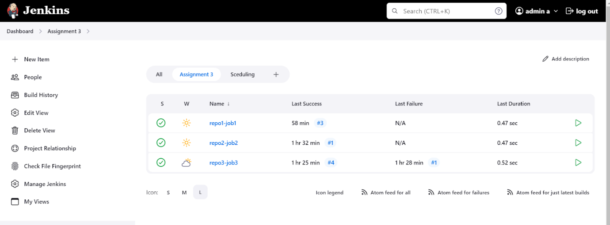

Step 4: each job has below properties:

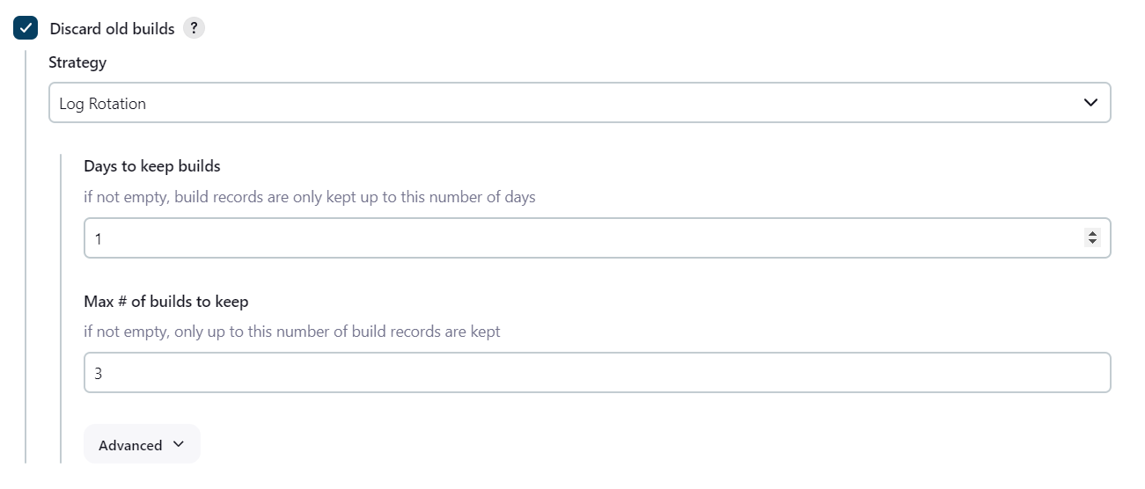

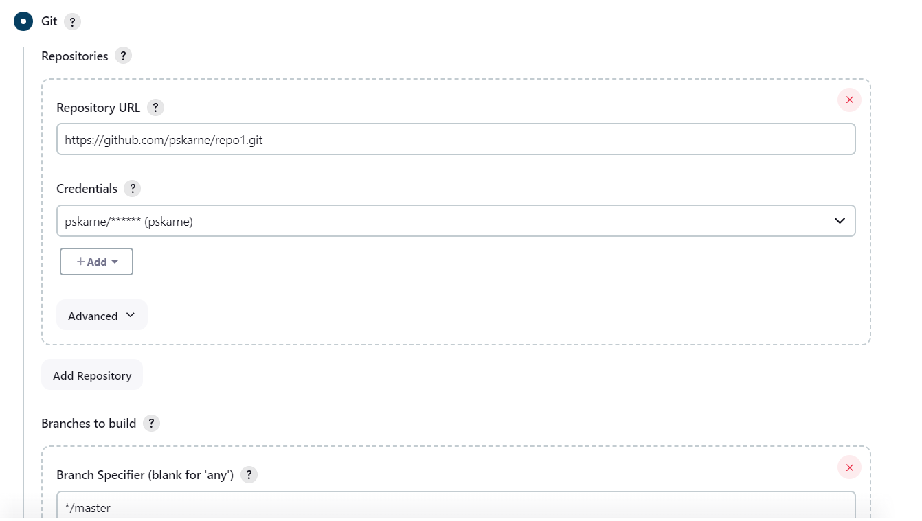

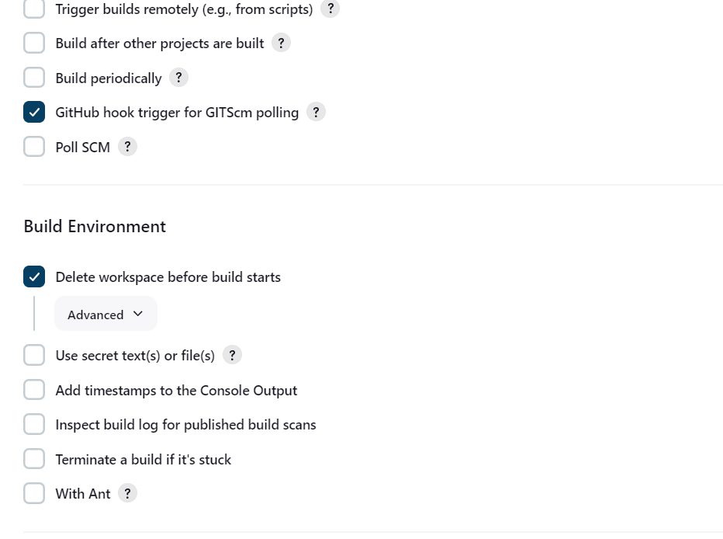

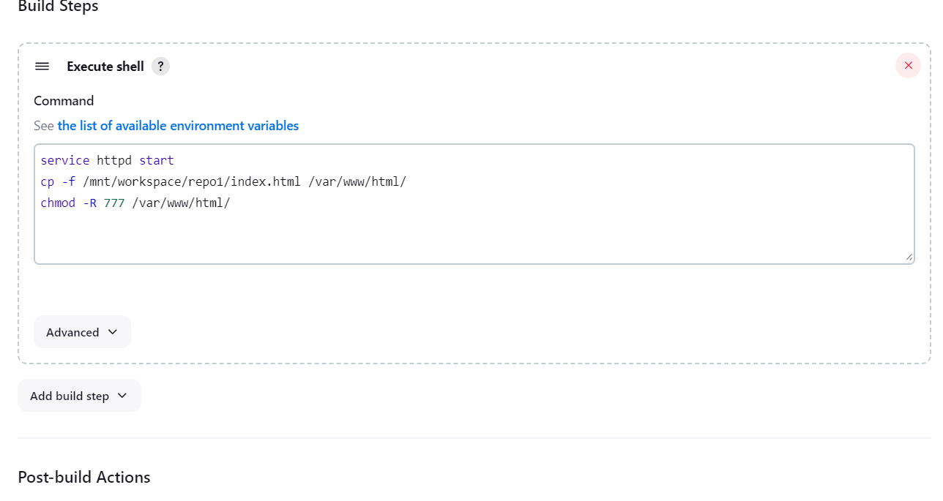

Step 4: Configured GitHub server - using secret text

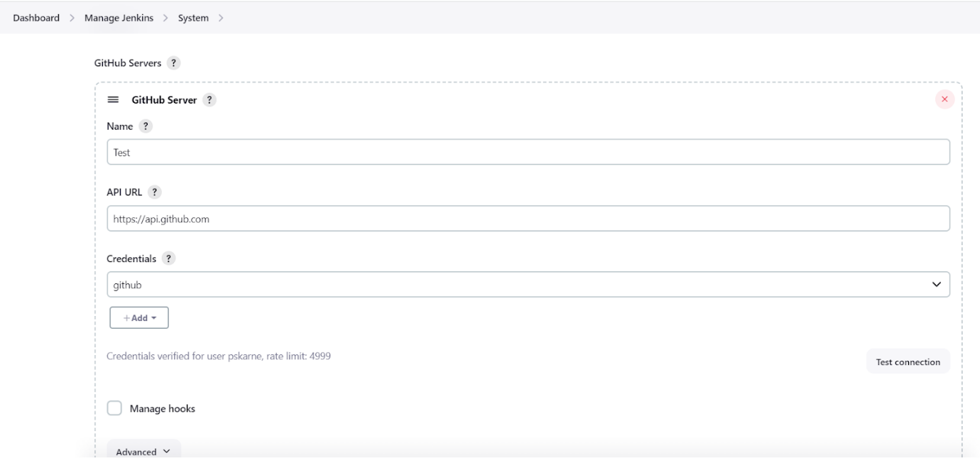

Step 5: on github repository added a webhooks for all three repos:

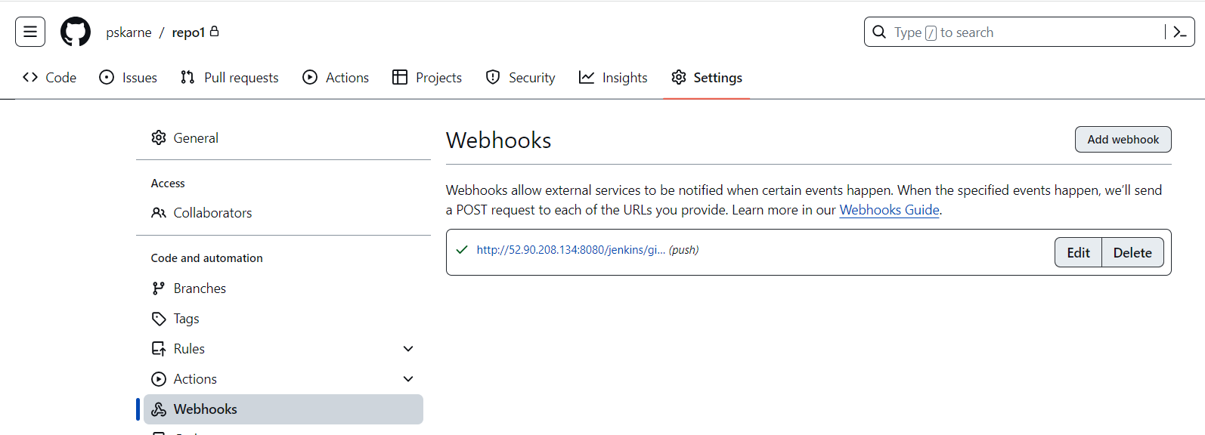

Step 6: Testing

All three jobs are executing successfully:

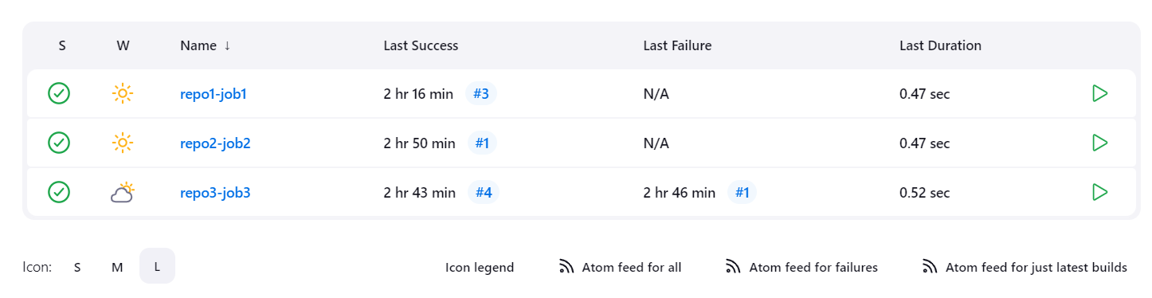

After triggering first job:



After triggering first job:

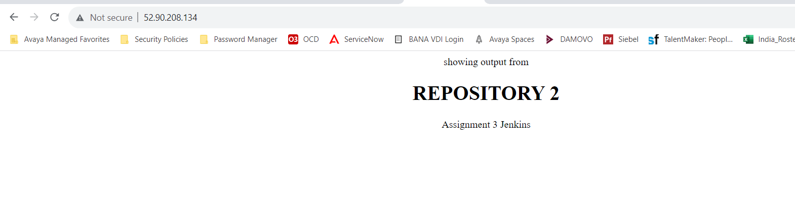

After triggering third job:

